**Script to start the ec2 instance and start the tomcat server at particular time….**

**Below I taken jenkins instance to work on it presently it is stopped below image shown clearly…**

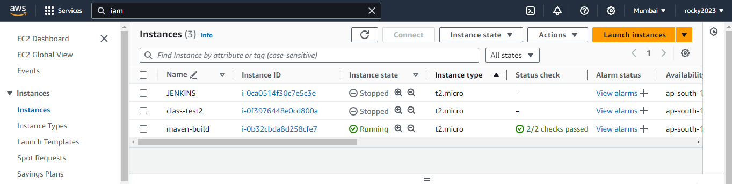

**Here script executed in cli stopped instance is going to start and run tomcat server at particular set time….**

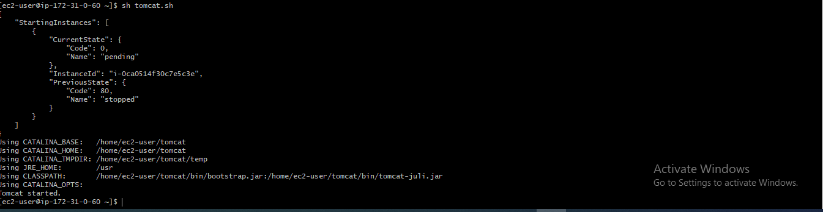

**Here now that jenkins instance has been started ….**

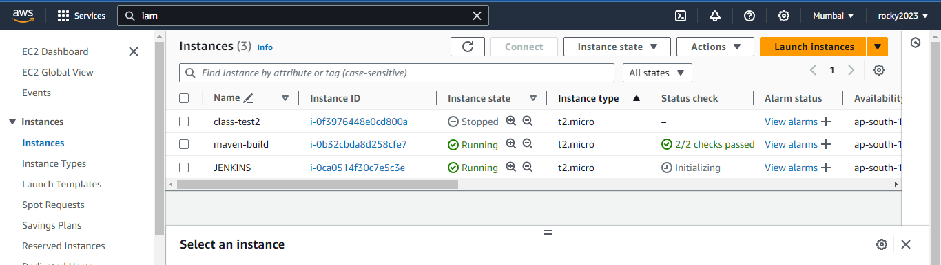

**Script fro running instance and to start tomcat server….**

